 | 12.1.1 Editors - Geometry Nodes Editor - Header - Tools and Options
Table of content
Introduction 1
Header Tabs 1
Geometry Nodes Prop 1
Data Browser 2
Edit box 2
Add Fake User 2
User 2
Remove 2
Options 2
Pin (pin icon) 2
Parent Node Tree 2
Snap 2

Introduction

This chapter here is about the tools, modes and options elements in the header of the geometry nodes editor.

The text menus are covered in a own chapter each. They vary too much, dependent of mode and object type.

Header Tabs

The tabs at the very left allows you to switch between the most important node editor types by one click. Compositor Editor, Geometry Nodes Editor and Shader Editor.

Geometry Nodes Prop

Manage the nodes. If there is no geometry node tree for the current object, then you will see the New button
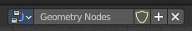

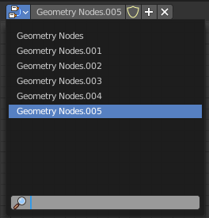
Data Browser
The list of available geometry node trees in the scene.

Edit box
The name of the current active geometry node tree. Here you can also rename the node tree.

Add Fake User
Wit this button you assign a fake user to this selected geometry node tree.
Data, like node trees, that is not longer linked to anything else gets removed when you save and reload a scene. Bforartists has the concept of fake users to go around this behavior. An image with a fake user is in fact linked to something. And so it is not lost when you save and reload the scene.

User
The number of users that uses this data. Data with a user number of 0 will be removed with closing Bforartists.

Remove
Removes the geometry node tree. To delete it completely you need to purge it. See Fake user.

Options

At the right side you will see some options.

Pin (pin icon)
The pin button will keep the current node tree selection fixed. When a node tree is pinned, it will remain visible in the shader editor even when another object is selected.

Parent Node Tree
Grouping nodes can simplify a node tree by allowing instancing and hiding parts of the tree. Nodes can be grouped. This button becomes active when you work with such grouped nodes, and you are in a child group. it allows you to switch to the parent group.

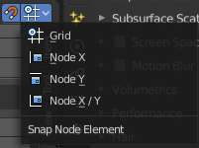
Snap
Activates snapping. When the tool is activated, then you will also reveal the snap settings where you can choose different snap methods.

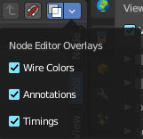
Geometry node Overlays

Show Overlays
Show or hide the overlays.

Node Editor Overlays

Wire Colors
Show the colors at the noodles.

Annotations
Show Annotations.

Timings
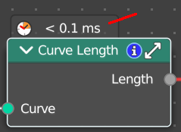
Shows a timing box above each node to indicate the evaluation time of it.

